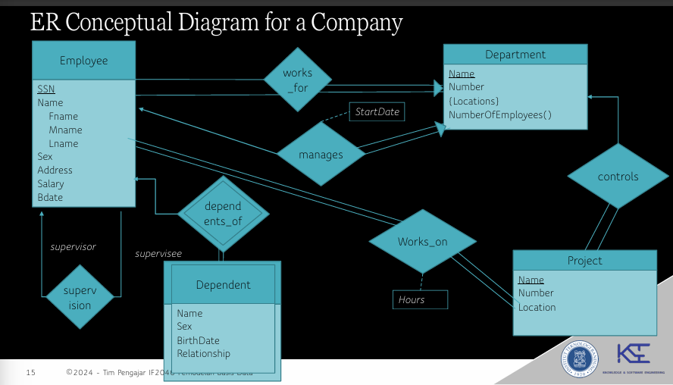
Employee = {SSN, DeptName, Fname, Mname, Lname, Sex, Address, Salary, Bdate, supervisorSSN}
Dependent = {SSN, DeptName, Sex, BirthDate, Relationship}
Department = {DeptName, Number, ManagerSSN, StartDate}
Project = {ProjName, Number, Location}
DeptLocation = {DeptName, Locations}

Dependent(SSN) → Employee(SSN)
Employee(DeptName) → Department(DeptName)
Dependent(DeptName) → Department(DeptName)
DeptLocation(DeptName) → Department(DeptName)

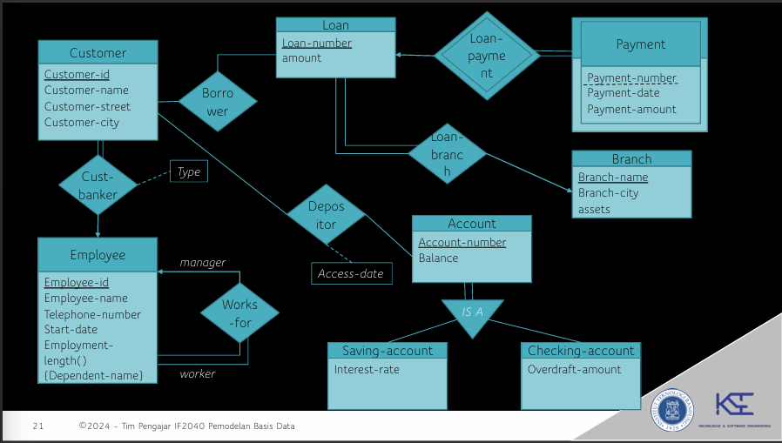
Customer = {customer-id, customer-name, customer-street, customer-city, banker, banker-type}
Employee = {employee_id, employee-name, telephone-number, start-date, Manager-id}
Loan = {Customer-id, loan-number, Branch-name, amount}
Payment = {Loan-number, Payment-number, payment-date, payment-amount}
Branch = {Branch-name, branch-city, assets}
Account = {Account-number, balance}
Saving-account = {Account-number, Balance, Interest-rate}
Checking-account = {Account-number, Balance, Overdraft-amount}
Cust-banker = {Customer-id, Employee-id, Type}
Depositor = {Account-number, Customer-id, access-date} #many-to-many
Loan-Branch = {Loan-number, Branch-name}
EmployeeDependent = {Employee-id, Dependent-name}

Cust-Banker(Customer-id) → Customer(Customer-id)

Relasi barang gbs ilang krn partial participation, jd harus punya 3 relasi yaitu barang, batukekuatan, dan pokeball

